Proseminar Rechnerarchitektur Zettel 02

Aufgabe 1)

Ein Bild, das Tisch enthält.

y = x̅1̅ x̅2̅ + x̅1̅ x2 = not x1 🡨 1. Negation

Ein Bild, das Tastatur enthält.

Y = x1 + x2 + x3 <- Disjunktion = OR

Aufgabe 2)

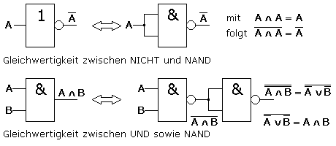

|  |  |  |  |  |  |
| --- | --- | --- | --- | --- | --- |
| A | B | A und B | Not(AundB) | Not (nand) |  |
| 0 | 0 | 0 | 1 | 0 |  |
| 1 | 0 | 0 | 1 | 0 |  |
| 0 | 1 | 0 | 1 | 0 |  |
| 1 | 1 | 1 | 0 | 1 |  |

Ein Bild, das Text, Uhr enthält.

|  |  |  |  |  |  |  |
| --- | --- | --- | --- | --- | --- | --- |
| A | B | A oder B | Not A | Not B | notA u notB | Not (notA und notB) |
| 0 | 0 | 0 | 1 | 1 | 1 | 0 |
| 1 | 0 | 1 | 0 | 1 | 0 | 1 |
| 0 | 1 | 1 | 1 | 0 | 0 | 1 |
| 1 | 1 | 1 | 0 | 0 | 0 | 1 |

3)

|  |  |  |  |  |
| --- | --- | --- | --- | --- |
| A | B | C | D | Y |
| 0 | 0 | 0 | 0 | 1 |
| 0 | 0 | 0 | 1 | 0 |
| 0 | 0 | 1 | 0 | 0 |
| 0 | 0 | 1 | 1 | 1 |
| 0 | 1 | 0 | 0 | 0 |
| 0 | 1 | 0 | 1 | 1 |
| 0 | 1 | 1 | 0 | 1 |
| 0 | 1 | 1 | 1 | 1 |
| 1 | 0 | 0 | 0 | 0 |
| 1 | 0 | 0 | 1 | 1 |
| 1 | 0 | 1 | 0 | 1 |
| 1 | 0 | 1 | 1 | 1 |
| 1 | 1 | 0 | 0 | 1 |
| 1 | 1 | 0 | 1 | 1 |
| 1 | 1 | 1 | 0 | 1 |
| 1 | 1 | 1 | 1 | 0 |

Y = (D + C + B + A)*(A̅B̅C̅D̅)

4)

|  |  |  |
| --- | --- | --- |
| X1 | X2 | y |
| 1 | 1 | 0 |
| 0 | 1 | 1 |
| 1 | 0 | 1 |
| 0 | 0 | 0 |

a) y=(x̅1x2)+(x1x̅2)

b) 0,75*0,6 =0,45| 0,40*0,25= 0,10

0,1+0,45=0,55